GIBRAN RUBINGER

Guided Technology Project 2020 | cct -dUBLIN COLLEGE

STOCK WALLET

CLOUD-BASED WEB APPLICATION

23.06.2020 - Tuesday

I received from Ken and Amilcar the ok to proceed with my project during the session guided project today. The first step to start the project, I created a Git repository to track all the changes during this project:

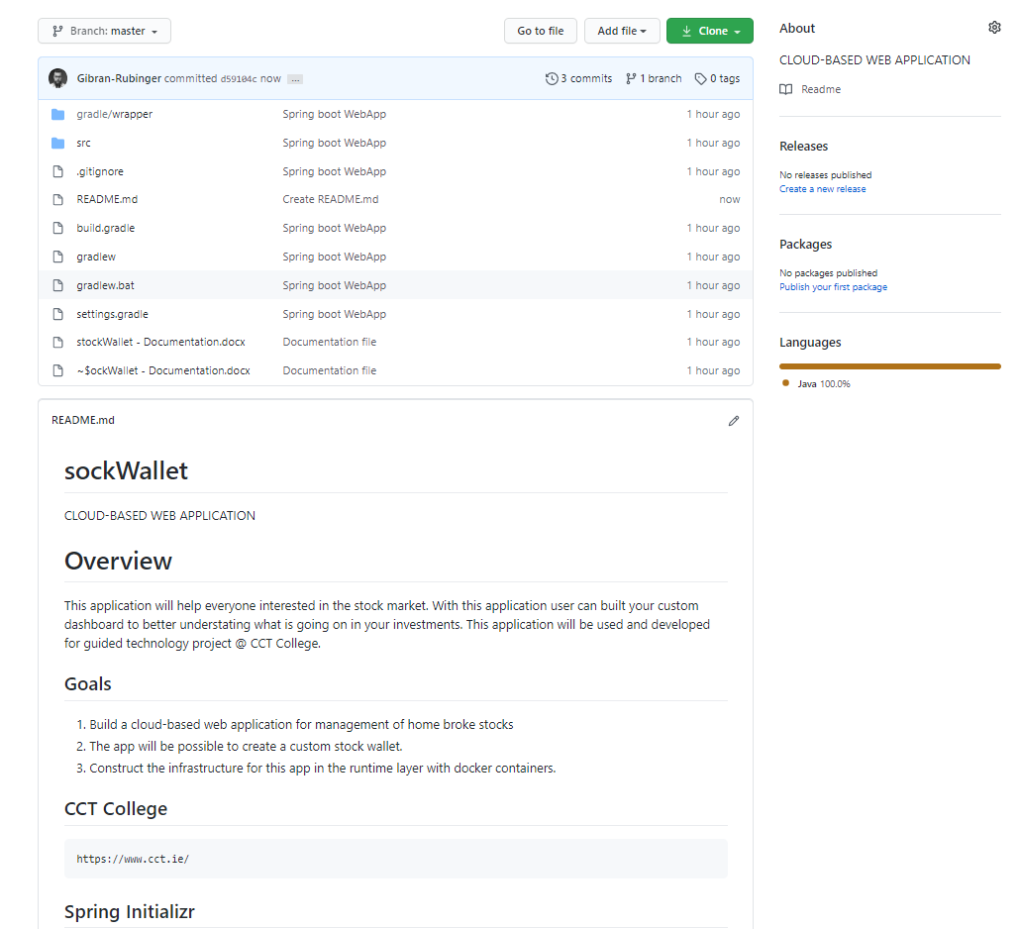

Figure 1-Screenshot of the GitHub repository

As the git repository and the markdown code to overview the project is already done, I will try to start the project building a RES API. First of all, to start the development of this Rest API I will use the Spring Boot to generate an empty project with Spring web dependencies.

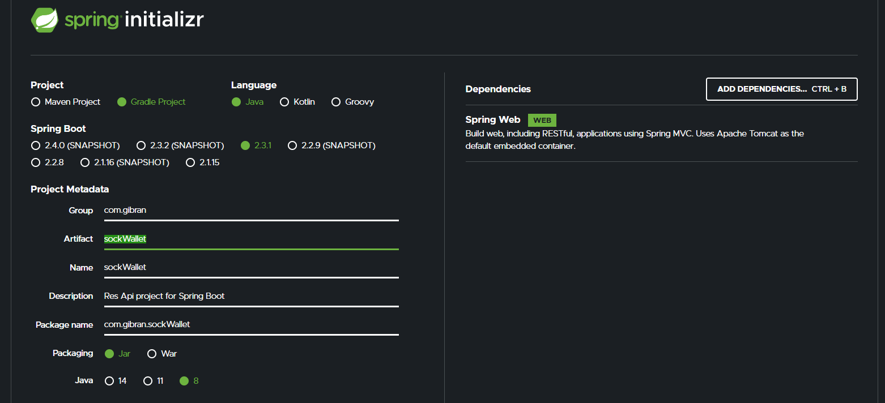

Figure 2-Screenshot of the creation RestApi – Spring Boot to generate the empty project.

As to clarify what the RES API does the article written by Zell Liew on the Website [smashingmagazine.com](https://www.smashingmagazine.com/2018/01/understanding-using-rest-api/) start with a simple explanation to have an idea what the REST API does:

*“Let’s say you’re trying to find videos about Batman on YouTube. You open up YouTube, type “Batman” into a search field, hit enter, and you see a list of videos about Batman. A REST API works in a similar way. Your search for something, and you get a list of results back from the service you’re requesting from.”*

**API**

The API is responsible to build the applications interface solutions into the server to allow the access and control of clients’ request.

**REST**

The rest will build the configurations of how the API will be settled. As Zell explains:

*“It is a set of rules that developers follow when they create their API. One of these rules states that you should be able to get a piece of data (called a resource) when you link to a specific URL.”*

What is happening on the figure1?

* first its setting witch building tool we want to use. As during the course, we used to use Grade I choose Gradle to automate the JVM.
* It must choose the language we will build on. In my case is Java.
* It will choose the version we are using in Spring Boot in 2.3.1
* fill-up the project metadata with name
* choose the packaging java Application, in my case I will be using Jar as an artefact and deploying that in a single environment that we can use the application in any bare remote machine.
* Choose the java version that matches with my system, 1.8.
* And adding the Spring Web as dependencies

After I download the RestAPI, unzip the files and set up a new workplace in my Eclipse IDE and start to import the Gradle file.

IDE:

Then I integrated Development Environment as the name already explains, is a helper tool for developers that we can write down codes faster than using a text editor. Also, the IDE provides debugger and compiler everything.

**Adding Controller Class**

To able Spring boot find the scanner to connect the Http protocol into the java code I create new class stockWalltController to mapping the request in Http by using annotations for with methods I will use inside this controller.

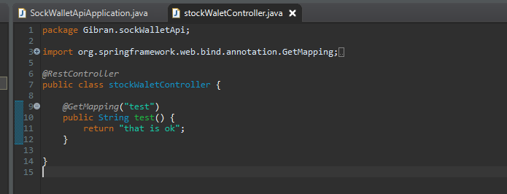

Figure 3– screenshot of the creation of the class controller.

25.06.2020 – Thursday

Today After search for long time I found a open sourse Gantt Chart project management that really works Agantty. Before to get this one I had download some previus but wasn’t work properly. How with a correct tool will be possible to track all the task nessesary for this project.

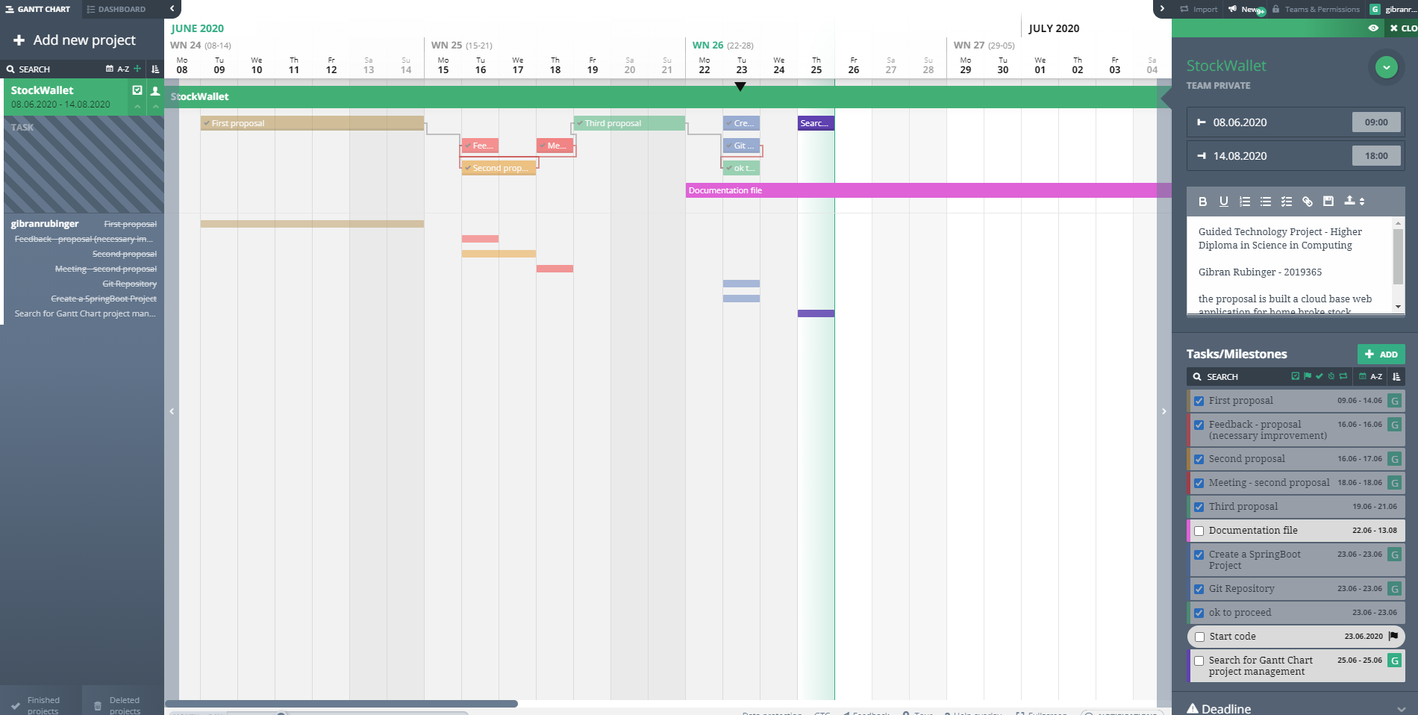

Figure 4– screenshot of the Agantti App

26.06.2020 – Friday

Today in my first task, I finnish the the scope for my draft plan (project managment):

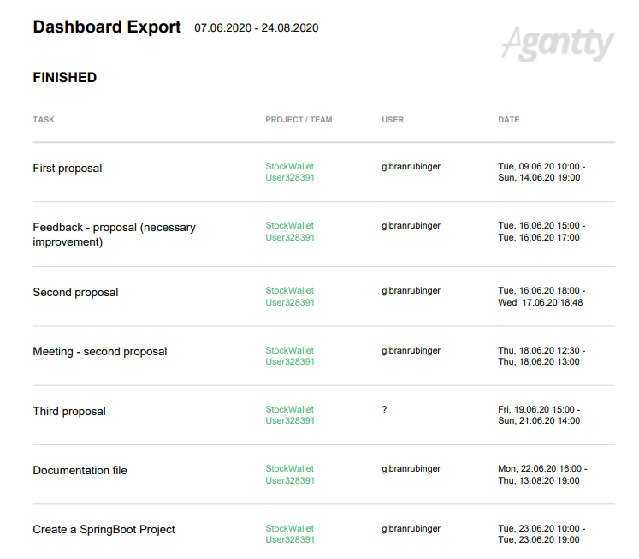

Figure 5 – Screenshot of the dashboard project.

27.06.2020 – Saturday

Today I decide to search about the ISEQ20 and Euronext Dublin, I am trying to understand how the Irish benchmark works.

The ISE20 is a benchmark [stock market index](https://en.wikipedia.org/wiki/Stock_market_index) composed of companies that trade on [Euronext Dublin](https://en.wikipedia.org/wiki/Euronext_Dublin). The index comprises the 20 companies with the highest trading volume and [market capitalisation](https://en.wikipedia.org/wiki/Market_capitalisation) contained within the ISEQ Overall Index. The index was started on 31 December 2004 at a base of 1,000 points. The Irish Overall Index has a longer history and is more often used for comparing the performance of the Irish stocks for a longer period.

At Monday (28.06.2020) I will be able to see the market in realtime to understand better how pre prices are send to the market and Iwill identify the better brace to take the stock information.

28.06.2020 – Sunday

Today I start to made the databse mormalisation,